UNIVERSIDAD ANÁHUAC MAYAB • DIVISION OF ENGINEERING
LABORATORY ACTIVITY 16: MULTI-MODEL REGRESSION
COMPARISON & DIAGNOSTICS BAKE-OFF
Predictive Modeling: OLS Fitting, Multi-Model Selection, & Residual Health Checks
Course & Period: | Data Mining & Modern AI Systems (IIND4417) — Academic Period: 202660
Class Session Alignment: | Session 19: Unit 5.2 Optimization & 5.3 Assumption Diagnostics
Instructor: | Dr. Víctor Cardoso
Team Assigned Database: | Team 3 — EV Battery
Student Names & IDs: | 1. ___________________ 2. ___________________ 3. ___________________  4. ___________________ 5. ___________________ 6. ___________________

🎯 THE MULTI-MODEL BAKE-OFF CHALLENGE: In real-world data science and AI engineering,
you never fit just one model and blindly trust it. Today, your team will configure 5 distinct regression models on your assigned industry database. You will evaluate their R², Adjusted R², MAE, and RMSE metrics, examine their residual diagnostic health checks, and defend which model represents the true 'Best Fit' for your client.

Objective & Engineering Mission
As we transition into predictive modeling for continuous numerical outcomes (regression), engineers must balance two competing forces: explanatory power versus model complexity. Adding more variables to a linear model will almost always increase the raw R² score—even if those variables are completely irrelevant noise! To prevent building overcomplicated models, engineers evaluate Adjusted R² (which penalizes useless predictors) and inspect residual health checks.

By the end of this laboratory activity, your team will:
- Ingest your team's assigned domain database and understand its continuous target variable.
- Configure 5 distinct candidate regression models with varying feature combinations.
- Train all 5 models using an identical 80/20 train/test split to guarantee fair, rigorous benchmarking.
- Log R², Adjusted R², MAE, and RMSE across all 5 models in a clean comparison table.
- Generate residual diagnostic plots (Fitted vs. Residuals and Q-Q plots) to verify regression health.
- Defend the single 'Best-Fit' model based on statistical evidence, physical interpretability, and client ROI.

Team Database Assignment Reference Table
To emulate specialized engineering squads and prevent cross-team code sharing, each team is assigned a completely distinct real-world telemetry dataset. Download your assigned CSV file from the course repository or Brightspace:
Team # & Domain |  | Assigned CSV File |  | Target Variable (y) | Predictor Pool (Features X)
Team 1: Solar Power regression_team1_solar.csv power_output_kw solar_irradiance_w_m2, (Kilowatt output) ambient_temp_c, wind_speed_m_s, panel_temp_c, sun_elevation_deg, dust_accumulation_pct
Team 2: Semiconductor | regression_team2_semiconduc  tor.csv | wafer_yield_pct  (Yield %) | rf_power_watts, chamber_pressure_torr, etching_time_sec,  gas_flow_sccm, wafer_temp_c, cleanroom_humidity_pct
Team 3: EV Battery | regression_team3_ev_battery.c sv | battery_cell_temp_c  (Cell temp °C) | discharge_current_a, ambient_temp_c, state_of_charge_pct, internal_resistance_mohm, coolant_flow_l_min, cell_voltage_v
Team 4: Biomedical ICU | regression_team4_biomedical. csv | cardiac_output_l_min  (Blood flow L/min) | heart_rate_bpm, stroke_volume_ml, systolic_bp_mmhg, mean_arterial_pressure_mmhg , systemic_vascular_resistance, blood_oxygen_pct
Team 5: Smart Grid regression_team5_smartgrid.cs active_power_load_mw industrial_consumption_mw,
v (Grid load MW) ambient_heat_index_c,
residential_meter_count, transformer_temp_c, reactive_power_mvar, grid_frequency_hz

The 5-Model Candidate Architecture
Your team must configure, fit, and evaluate the following 5 distinct candidate regression models on your assigned dataset. Notice how each model progressively expands in complexity:

- Model 2 (Primary Operational Pair — 2 Features): Add the second most important physical driver. Observe how much variance is explained by this core operational pair.
- Model 3 (Tri-Variate Core — 3 Features): Incorporate a third variable (such as an environmental or process control factor). Check if the addition produces a noticeable drop in RMSE.
- Model 4 (Operational Multi-Variable — 4 Features): Add a fourth auxiliary variable. Watch what happens to the gap between raw R² and Adjusted R².

Step-by-Step Laboratory Execution Guide
- Step 1: Feature Branching in VS Code GUI: Open VS Code and navigate to your team repository. In the bottom-left status bar, click on 'main' and select 'Create new branch'. Name your branch: feature/activity-16regression-models. Open the Source Control panel (Ctrl+Shift+G).
- Step 2: Ingest Assigned Dataset & Split (80/20): Load your team's assigned CSV file into pandas. Separate your feature matrix X and target vector y. Execute an 80/20 train/test split using train_test_split(X, y, test_size=0.20, random_state=42). Note: random_state=42 is mandatory so all 5 models are evaluated on the exact same test records!
- Step 3: Fit All 5 Regression Models: Using Scikit-Learn's LinearRegression(), fit each candidate model on X_train[selected_features] and y_train. Generate predictions on both the training set and the test set.
- Step 4: Compute Fit Statistics & Error Metrics: For every model, calculate: (1) Training R², (2) Testing R², (3) Adjusted R² (penalized for feature count), (4) Mean Absolute Error (MAE), and (5) Root Mean Squared Error (RMSE).
- Step 5: Visual Residual Diagnostics (Health Checks): For your top 2 candidate models, compute the test residuals (Residual = y_test - y_pred). Create a 2-panel diagnostic chart: (a) Fitted Values vs. Residuals scatter plot to check for homoscedasticity (equal variance) and linearity, and (b) Residual Histogram or Q-Q plot to verify normality.
- Step 6: Defend the Winning Model & Sync with GitHub: Compare your 5 models in the deliverable table. Write a 2-3 paragraph technical defense justifying your chosen 'Best-Fit' model. Stage your script, commit with message 'feat(regression): complete 5-model bake-off comparison', publish branch, open a GitHub PR, have a teammate review and approve, and merge into main.

Student Results Workspace & 5-Model Comparison Table
Log your team's empirical modeling results in the benchmark table below. Every team member must understand these numbers for in-class verification:
Model | Features Selected | Train R² | Test R² | Adjusted R² | MAE | RMSE
Model 1 | ambient_temp_c | 0.4741 | 0.5013 | 0.4976 | 5.9710 | 7.6583
Model 2 | ambient_temp_c  discharge_current_a | 0.7229 | 0.7708 | 0.7674 | 4.2614 | 5.1917
Model 3 | ambient_temp_c  discharge_current_a  coolant_flow_l_min | 0.9079 | 0.9138 | 0.9118 | 2.6133 | 3.1847
Model 4 | ambient_temp_c  discharge_current_a  coolant_flow_l_min  internal_resistance_mohm | 0.9733 | 0.9755 | 0.9748 | 1.3574 | 1.6962
Model 5 | ambient_temp_c  discharge_current_a  coolant_flow_l_min  internal_resistance_mohm  state_of_charge_pct | 0.9813 | 0.9835 | 0.9829 | 1.1355 | 1.3936

🏆 WINNING MODEL SELECTION & CLIENT DEFENSE
Which of the 5 models does your team designate as the 'Best Fit' for production deployment? Explain your reasoning in 2-3 paragraphs below. Address: (1) Why did this model beat the others? (2) Is the gain in Adjusted R² worth the cost of collecting and maintaining those additional sensor features? (3) Did the residual plots confirm that the model satisfies linearity and equal spread?

The team designates Model 5 as the best fit for production deployment. It achieved the highest test R² (0.9835) and adjusted R² (0.9829), while also producing the lowest MAE (1.1355 °C) and RMSE (1.3936 °C). Its test score is slightly higher than its training score (0.9813), so the result does not indicate harmful overfitting under the common 80/20 split.
The fifth predictor, state of charge, improves adjusted R² from 0.9748 to 0.9829 and reduces RMSE from 1.6962 °C to 1.3936 °C relative to Model 4. Because state of charge is normally available from the battery-management system, this error reduction justifies the limited added collection and maintenance cost. Cell voltage was not included because it had the weakest absolute linear correlation with cell temperature in this dataset.
The residual diagnostics also favor Model 5. Its residuals remain more tightly concentrated around zero and show a more consistent spread than Model 4, supporting the linearity and constant-variance assumptions. The Model 5 Q-Q points follow the reference line closely through most of the distribution, with only mild deviations in the tails. Model 4 displays a visibly larger residual spread and stronger tail departures. Together with the test metrics, these checks support selecting Model 5 as the most accurate and reliable candidate.

📈 RESIDUAL DIAGNOSTIC DASHBOARD (PASTE SCREENSHOTS)
Figure 1. Residual and Q-Q diagnostics generated for Models 5 and 4.
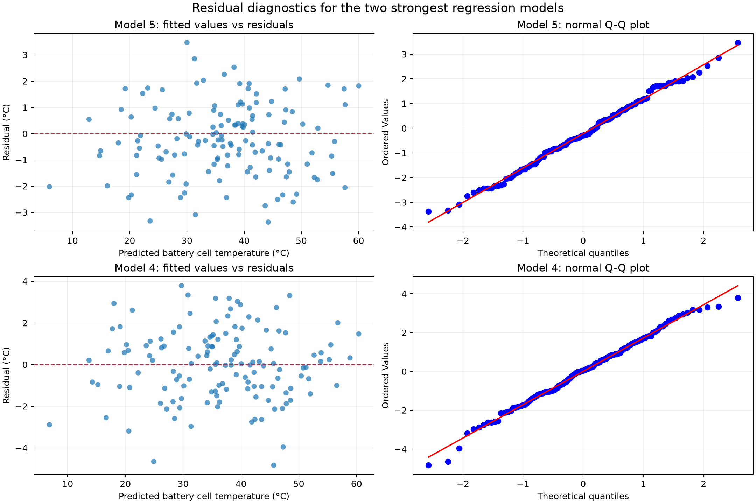
Evidence 1. Generated residual dashboard opened in VS Code.
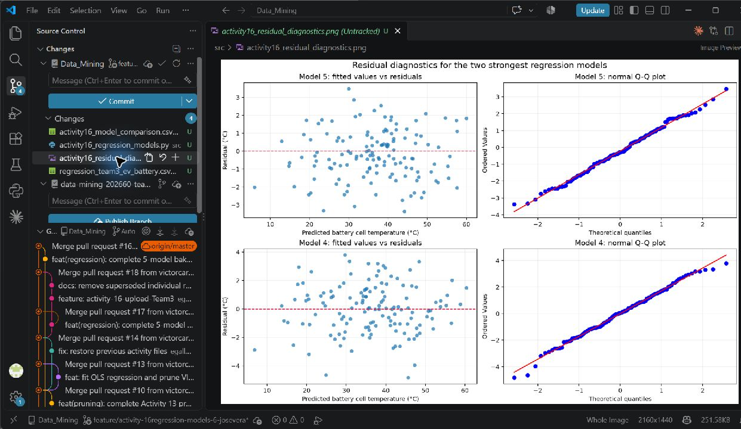
Evidence 2. VS Code terminal output showing the five-model comparison and saved artifacts.
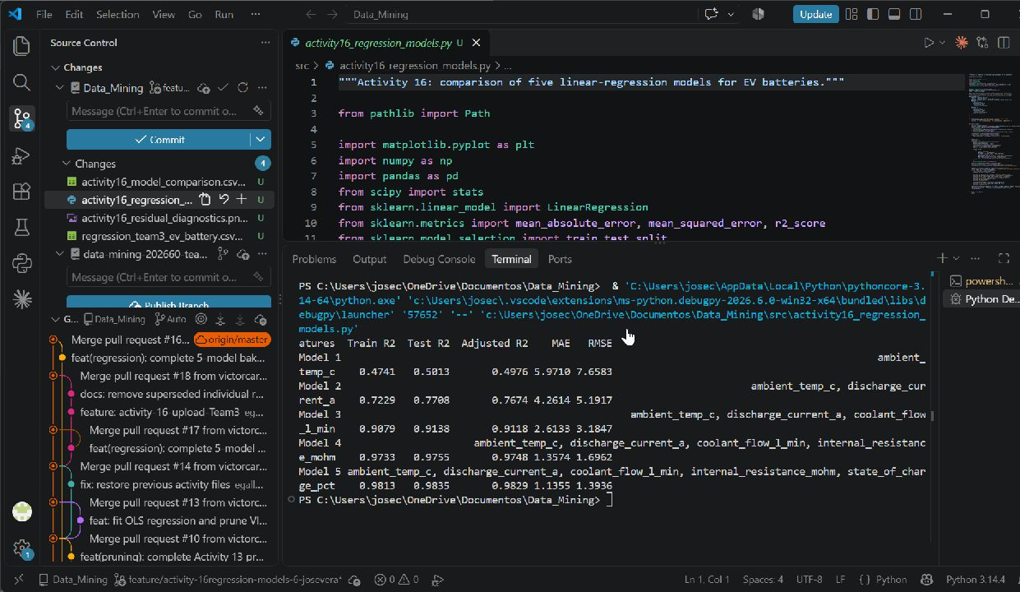
Panel A: Fitted Values vs. Residuals Scatter Plot (checking equal spread / homoscedasticity) Panel B: Normal Q-Q Plot or Residual Error Distribution Histogram ]

Responsible AI Pair-Programming & Troubleshooting Log
AI Tooling Utilized: | ChatGPT / Codex for code drafting, metric verification, interpretation, and document preparation.
Verbatim Prompts Submitted: | Prepare five LinearRegression models using one fixed 80/20 split; report train R², test R², adjusted R², MAE, and RMSE; create residual and Q-Q diagnostics for the top two models.
AI Code Output & Suggestions: | A reusable Python script with validated columns, nested feature sets, a model-training loop, comparison CSV export, and a two-model residual diagnostic figure.
Human Audit & Verification: | The script was executed in VS Code using one shared 80/20 split with random_state=42. The printed metrics were checked against the comparison table, the residual figure was inspected, and terminal and plot screenshots were incorporated as execution evidence.
Limitations & Bugs Caught: | The assignment lists six candidate predictors although Model 5 requires five. Cell voltage was excluded because it had the weakest absolute correlation with the target. Adjusted R-squared was calculated on the common test set using n=136 and each model's actual predictor count; column and missing-value validation were also included.
7. Activity Evaluation Rubric
Evaluation Pillar Excellent Developing Needs Improvement
1. 5-Model Configuration & Successfully configures, trains, Configures 3-4 models, or Fails to configure
Pipeline Implementation and tests all 5 regression models models are fitted on multiple models, script on identical 80/20 split. Features inconsistent splits, making crashes, or only fits a are logically grouped from comparison partially flawed. single baseline simple baseline to full regression. engineering model.
2. Metric Evaluation &  Comparison Table Accuracy | All metrics (Train R², Test R², Adjusted R², MAE, RMSE) are accurately computed and recorded in the comparison table with zero calculation errors. | Metrics are recorded, but 1-2 numbers are miscalculated (e.g., using train error instead of test, or omitting Adjusted R²). | Comparison table is incomplete, missing error metrics, or values are clearly fabricated without script execution.
3. Residual Diagnostics & Best  Model Defense | Generates clean Fitted vs.  Residuals and Q-Q plots. Identifies whether assumptions hold. Provides a compelling 2-3 paragraph defense of the winning model. | Residual plots generated but  lack clear labels or interpretation. Defense is brief or focuses only on raw R² without considering trade-offs. | No residual diagnostics provided, or team cannot articulate why their selected model was chosen.
4. Git Architecture &  Responsible AI Log | Clean feature branch in VS Code  GUI, atomic conventional commit (feat:), PR opened and approved by teammate, merged to main. AI log is thoroughly documented. | Code pushed to GitHub, but committed directly to main, generic commit message, or AI log lacks specific prompt auditing. | Code missing from remote GitHub repository, merge conflicts unresolved, or AI log is blank.

